Toronto Argonauts Alumni Association
19th Annual Golf Fun Day

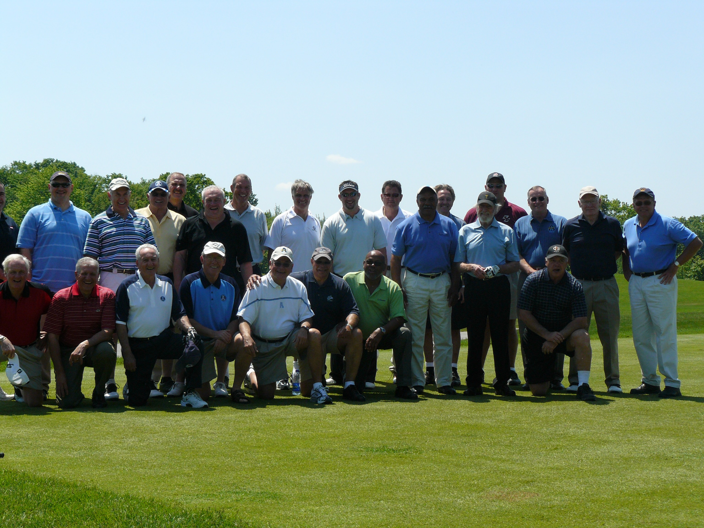
Toronto Argonauts Alumni Association

19th Annual Golf Fun Day

Monday, June 5th, 2017
At Eagle Ridge Golf Club
Mayfield Road North (10th Line) Georgetown, Ontario
Tel: 905.877.8468

Green Fees:

$165 (individual golfers)
$660 (Team of 4)
$40 Dinner Only

Included in Green Fees:

. 18 Holes of Golf and Cart
. BBQ Lunch
. Roast Beef Dinner Buffet
. Hole Events
. Goodie Bags

Hole Sponsorship:

$200 per Hole

Itinerary:

11 :00 am - Registration & BBQ Lunch
12:15 pm - To Designated Holes
12:30 - Shotgun Start
6:00 pm -Cocktails (Cash Bar)
6:30 pm – Dinner



For further information, contact:

Peter Martin
Tel: 289-837-4892
Email: petemartin77@gmail.com





registration form

I would like to register ___________ Teams @$660 each
I would like to register ____________Golfers @ $165 each
I would like to book _______________Hole Sponsorships @ $200 each
I would like to register ____________ Dinners @ $40 each

team/individual

Company name/Contact name _________________________________________________

Address ________________________________________________________________________

City/Province/Postal Code __________________________________________ ____________

Telephone ____________________________________________________

Email ___________________________________________________________________

team members

Player 1 ________________________________________________________

Player 2 ________________________________________________________

Player 3 ________________________________________________________

Player 4 ________________________________________________________

Please make cheque payable to: Toronto Argonauts Alumni Association

Mail to: Toronto Argonauts Alumni Association Golf c/o 2282 Parkglen Ave.
Oakville Ont. L6M 4R3

In order to avoid disappointment please confirm your registration with early payment. Post-dated cheques are accepted.

PAYMENT REQUESTED PRIOR TO MAY 15th, 2017

